AMORAA MATCH ENGINE
Business and Technical Architecture Report
Complete End to End Matching Compatibility Recommendation and Match Creation Workflow

Project: AMORAA / AMORA-AI
Document Type: Senior Management and Technical Reference
Match Engine Status: Complete
Current Recommendation Provider: LOCAL Deterministic Recommendation Engine
Certification Basis: Current working tree and final certification dated 29 September 2026

Table of Contents
Table of Contents 2
Certified Status at a Glance 5
How to Use This Report 5
Part I Management Overview 6
1 Executive Summary 6
2 What Is the Match Engine 6
3 Purpose of the Match Engine in AMORAA 6
4 High Level Matching Journey 6
Part II Data Preferences and Eligibility 7
5 User Data Used for Matching 7
6 Profile Fields Used by the Engine 7
7 Profile Completion and Eligibility 8
8 New User Behavior 8
9 Preferences and Filters 8
10 Age Matching 9
11 Gender and Interested In Matching 9
12 Location and Distance 9
13 Location Privacy 9
14 Interests and Lifestyle Matching 9
15 Hard Filters Versus Compatibility Factors 9
16 Candidate Eligibility Pipeline 10
17 Account State Handling 10
18 Blocks and Safety 10
19 User Interaction History 11
20 Swipe Behavior 11
21 Duplicate Profile Prevention 11
Part III Compatibility and Ranking 11
22 Compatibility Score 11
23 Compatibility Normalization 12
24 List Factor Matching 12
25 Scalar Factor Matching 12
26 Coverage 12
27 Compatibility Formula 12
28 Why Missing Data Is Not a Mismatch 12
29 Profile Shortlisting 13
30 Discover Ranking 13
31 Near You Ranking 13
32 AI Matches 13
33 AI Match Score 13
34 AI Confidence 13
35 AI Reasons 13
Part IV Delivery Pagination and Match Creation 14
36 Discover Feed Delivery 14
37 AI Matches Delivery 14
38 Cursor and Keyset Pagination 14
39 Discover Cursor Ranking 14
40 AI Match Cursor 14
41 Mutual Like to Match 14
42 After Match Creation 15
43 Message Flow from AI Matches 15
Part V Database API and Application Architecture 15
44 Database Architecture 15
45 Database Table Responsibility 15
46 Backend API Overview 16
47 Frontend to Backend Technical Flow 17
48 Error Handling 17
49 No More Matches Available 17
50 Filter Specific Empty State 18
Part VI Privacy Security Observability and Performance 18
51 Privacy and Consent 18
52 Security 18
53 Observability 18
54 Performance 18
55 Database Performance 19
56 Current Test Certification 19
57 Current APK and Environment Note 19
Part VII Examples and Frequently Asked Questions 19
58 Business Example 19
59 Match Engine Decision Example 20
60 Management FAQ 20
61 Technical FAQ 20
Part VIII Boundaries Roadmap and Complete Flow 21
62 Current Deliberate Limitations 21
63 Future Match Engine Improvements 21
64 Match Engine Versus AI 22
65 Complete End to End Flow 22
66 Final Management Summary 23
Appendices 23
Appendix A Compatibility Weight Reference 23
Appendix B Filter Reference 23
Appendix C Action Exclusion Matrix 23
Appendix D Database Table Reference 24
Appendix E Backend API Reference 24
Appendix F Error Code and Fallback Reference 24
Appendix G Test Certification Summary 24
Appendix H Glossary 24
Source and Implementation Reference 25

Certified Status at a Glance
Executive certification snapshot
Capability | Certified current state
Match Engine | Complete for the defined current product scope
Recommendation provider | LOCAL deterministic recommendation engine
Eligibility | Canonical, server-authoritative, shared by Discover and AI Matches
Reciprocity | Gender, age, and geographic distance
Compatibility | One authoritative eight-factor engine; SQL and JavaScript equivalent
Pagination | Signed, context-bound keyset cursors for Discover, Near You, and AI Matches
Privacy | Exact GPS, reciprocal limits, credentials, KYC, and messages excluded from public/AI contracts
Automated certification | Backend 311 passed; Flutter 627 passed; analyzer 0 errors
External model AI | Not implemented and not required for current completion

How to Use This Report
Parts I and II explain the business purpose, data, preferences, and eligibility rules. Parts III and IV explain scoring, ranking, pagination, Match creation, and chat. Parts V and VI provide database, API, privacy, security, observability, and performance references. Parts VII and VIII provide examples, FAQs, limitations, roadmap, and the complete workflow.
Management readers can focus on the executive summary, diagrams, policy tables, examples, and roadmap. Product, engineering, and QA teams can use the technical flows, formulas, API reference, error contract, database responsibilities, and appendices as the maintenance baseline.

Part I Management Overview

1 Executive Summary
AMORAA's Match Engine is the server-side decision system that determines which profiles a user may see, calculates explainable compatibility, orders eligible profiles, and delivers them to Discover and AI Matches. It replaces random profile display with consistent rules for safety, preferences, reciprocity, geography, interaction history, scoring, and pagination.
The engine is complete for the current defined product scope. Its recommendation provider is LOCAL and deterministic. No external model such as OpenAI, Gemini, or Claude selects candidates today, and an external model is not required for the current engine to function.
Business conclusion: AMORAA now has a traceable recommendation pipeline that respects both users, protects private location and account data, avoids repeated acted-on profiles, explains compatibility using stated profile evidence, and keeps later pages stable while the user swipes.

2 What Is the Match Engine
In simple terms, the Match Engine decides who can appear, how well each eligible profile aligns with the viewer, and which profile appears first. It covers eligibility, safety, preferences, reciprocity, distance, compatibility, ranking, pagination, and interaction history.
Technically, both Discover and AI Matches enter the same authenticated backend controller and the same candidate query. LOCAL AI can rerank only the candidate IDs that survive that query; it has no database path that can add an excluded profile.

3 Purpose of the Match Engine in AMORAA
- Make recommendations relevant to the viewer's explicit preferences.
- Respect the candidate's reciprocal gender, age, and distance preferences.
- Prevent repeated presentation after Pass, Like, Super Like, Match, or Block.
- Require a usable profile without confusing recommendation eligibility with optional 100 percent profile richness.
- Use real geography when coordinates are available while keeping exact coordinates private.
- Produce deterministic, explainable results that engineering and QA can reproduce.

4 High Level Matching Journey
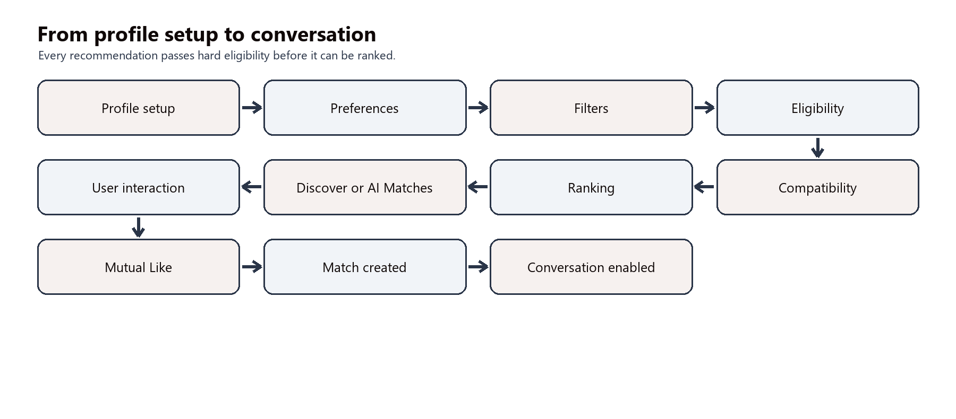
Figure 1. Management-level matching journey from profile setup through conversation.
The journey has two gates. Hard eligibility decides whether a profile may appear at all. Ranking then decides where an eligible profile appears. A strong compatibility score can improve rank, but it cannot override a block, an existing Match, reciprocal distance, or another hard rule.

Part II Data Preferences and Eligibility

5 User Data Used for Matching
Table 1. Matching data categories
Category | Source | How the engine uses it
Profile data | Onboarding and Edit Profile | Completion, age, gender, filters, compatibility factors, public profile
Preference data | Discover Filters | Viewer hard filters plus reciprocal age and distance ranges
Location data | Explicit Use Current Location action | Private Haversine distance and approximate public distance
Interaction data | Pass, Like, Super Like, Match, Block | Removes processed or unavailable relationships
System state | Account lifecycle, verification, activity, events | Candidate eligibility and selected hard filters

6 Profile Fields Used by the Engine
Table 2. Profile fields and recommendation roles
Field | Purpose | Role | Requirement
Birth date / age | Adult completion and mutual age eligibility | Eligibility / filter | Required
Gender | Explicit mutual interested-in comparison | Eligibility | Required
interestedIn | Viewer and candidate gender acceptance | Eligibility / reciprocal | Required
Relationship goals | Completion, hard intention filter, score | Eligibility / filter / compatibility | Required
City | Completion, optional exact filter, score | Eligibility / filter / compatibility | Required
Photos | Usable recommendation profile | Eligibility / public display | At least 2
Interests | Largest compatibility factor | Compatibility | Optional
Languages | Optional hard filter and score | Filter / compatibility | Optional
Communication style | Optional hard filter and score | Filter / compatibility | Optional
Smoking / drinking / weed | Optional hard filters and scores | Filter / compatibility | Optional
Profession / education / religion / community | Viewer-selected hard filters | Filter | Optional
Sexuality | Viewer-selected exact filter only; no attraction inference | Filter | Optional
Height / lifestyle / prompts | Viewer-selected hard filters | Filter | Optional
Verification / recent activity | Optional user-level hard filters | Filter | Optional
Match coordinates | Mutual geographic distance | Eligibility / ranking | Optional

7 Profile Completion and Eligibility
A recommendation-complete profile must have a valid adult birth date, a supported gender, at least one usable interestedIn value, at least one relationship goal, a non-empty city, at least two usable photos, onboardingCompleted=true, and stage='complete'. Blank values and 'Prefer not to say' do not satisfy required lists.
The engine rechecks current content, so stale completion flags cannot keep an incomplete candidate eligible. This rule is separate from AMORAA's optional 100 percent profile-richness indicator; recommendation matching does not require every optional profile field.

8 New User Behavior
An incomplete new user cannot use the normal recommendation pipeline. The API returns a controlled incomplete-onboarding response, and the product may guide the user to complete the required fields. Once the missing information is restored and the two completion flags are valid, the same account enters the pipeline without recreating the profile or restarting the full onboarding journey.

9 Preferences and Filters
Discover preferences are server-authoritative. Saved values are normalized, and approved request overrides take precedence for the current request. Canonical ranges are age 18-99, distance 1-300 km, height 137-213 cm, compatibility 0-100, and page size 1-30.
Table 3. Filter contract summary
Filter | Type or range | Current behavior
Age | 18-99 | Hard; reciprocal
Distance | 1-300 km | Hard when coordinates exist; reciprocal
Height | 137-213 cm | Viewer hard filter
City | Single exact value | Viewer hard filter and score factor
Dating intentions | List | Viewer hard filter; score uses profile goals
Sexuality | String | Viewer hard filter only
Education / profession | String | Viewer hard filters
Community / religion | String | Viewer hard filters
Smoking / drinking / weed | String | Viewer hard filters and score factors
Languages | List | Viewer hard filter and score factor
Pronouns / qualities | List | Viewer hard filters
Talking hours / love languages | List | Viewer hard filters
Lifestyle / communication | List / enum | Viewer hard filters; communication is scored
Prompts | Boolean | Viewer hard filter
Verified / recent activity | Boolean | Viewer hard filters
Registered event interest | Boolean | Viewer hard filter
Minimum compatibility | 0-100 | Viewer hard threshold

10 Age Matching
The viewer's age range first checks the candidate. The candidate's effective Discover preference then checks the viewer's exact age. For example, if A accepts ages 25-30 and B is 27, A accepts B; B must also have a range containing A's age. Both boundaries are inclusive.
Candidate reciprocal ranges come from DiscoverFilterPreference. A missing preference row uses runtime-aware defaults without writing a new row. Legacy out-of-range values are safely normalized.

11 Gender and Interested In Matching
The viewer's interestedIn list must accept the candidate's gender, and the candidate's interestedIn list must accept the viewer's gender. The contract recognizes supported aliases and the universal values everyone, all, any, and both. AMORAA does not infer attraction from sexuality; only explicit configured interest values are used.

12 Location and Distance
AMORAA stores private matchLatitude, matchLongitude, and server-owned locationUpdatedAt on the onboarding profile after an explicit foreground location action. The engine calculates great-circle distance using the Haversine method and Earth radius 6,371.0088 km. It never substitutes city equality for physical distance.
Distance is reciprocal. If A allows 50 km, B allows 20 km, and the exact distance is 15 km, the pair passes. At 30 km, A would accept B but B would not accept A, so the candidate is excluded. The boundary is inclusive and the same precise distance is checked against both limits.

13 Location Privacy
- Raw latitude and longitude are never returned in public recommendations.
- The public UI receives only whole-kilometre approximate distance.
- Location is requested through an explicit foreground action; there is no background GPS stream.
- No automatic location-expiry policy is currently defined.
- Default Discover and AI Matches remain available to legacy viewers without coordinates; Near You requires coordinates.
- Private coordinates and reciprocal limits are not placed in LOCAL AI evidence, logs, or cursor payloads.

14 Interests and Lifestyle Matching
Compatibility uses interests, relationship goals, communication style, languages, city, smoking, drinking, and weed. Other profile fields can still act as hard filters, but they do not silently add score weight. This separation keeps score interpretation stable and prevents the UI from creating a second scoring model.

15 Hard Filters Versus Compatibility Factors
Table 4. Eligibility and scoring are separate decisions
Field | Can exclude | Affects score | Reciprocal
Age | Yes | No | Yes
Gender interestedIn | Yes | No | Yes
Distance | Yes | No | Yes
Interests | No | Yes - 35 | No
Relationship goals | Yes when intention filter selected | Yes - 25 | No
Communication style | Yes when selected | Yes - 10 | No
Languages | Yes when selected | Yes - 10 | No
City | Yes when selected | Yes - 5 | No
Smoking / drinking / weed | Yes when selected | Yes - 5 each | No
Profession, education, religion, community | Yes when selected | No | No
Verified, activity, event, prompts | Yes when selected | No | No

A hard filter determines whether a candidate may appear. A compatibility factor determines how strongly an already eligible profile aligns. Eligibility always wins over score.

16 Candidate Eligibility Pipeline
- Exclude the viewer's own user ID and require an active candidate account.
- Require current canonical profile completion.
- Remove either-direction blocks, existing Matches, and prior Pass, Like, or Super Like actions.
- Apply viewer gender, age, and all selected hard filters.
- Apply candidate reciprocal gender and age acceptance.
- When geographic filtering is active, require valid candidate coordinates and enforce both distance limits.
- Calculate canonical compatibility and apply minimum compatibility if configured.
- Rank the remaining candidates and select the keyset page.

17 Account State Handling
Table 5. Lifecycle behavior
State | Recommendation behavior
Active | May participate if every other rule passes
Deactivated | Cannot authenticate normally and is excluded as a candidate
Reactivated | Same profile may become eligible again without recreation
Deleted | Excluded from authentication and recommendation eligibility

18 Blocks and Safety
Blocks are bidirectional: if either user blocks the other, the pair is excluded from Discover, AI Matches, and relationship actions. A report alone does not automatically create a block or remove a candidate. The profile is removed only when another canonical rule, such as a block or lifecycle change, makes it ineligible.

19 User Interaction History
Table 6. Action exclusion policy
Interaction | Excludes from recommendations | Current policy
Pass | Yes | DiscoverAction remains
Like | Yes | DiscoverAction remains
Super Like | Yes | DiscoverAction remains
Existing Match | Yes | While Match exists; action may still exclude after unmatch
Block | Yes | While either-direction block exists
Rose | No | Independent Rose transaction
Save | No | Independent SavedProfile
Report | No | Independent safety case

20 Swipe Behavior
Pass, Like, and Super Like are persisted as DiscoverActions. The actor-target pair is unique, so repeated actions do not create duplicate rows. Rewind removes the viewer's most recent DiscoverAction; the profile may return only if no Match, block, or other eligibility rule still excludes it.

21 Duplicate Profile Prevention
Backend exclusions remove profiles already processed through Pass, Like, Super Like, Match, or Block. Deterministic ordering plus keyset continuation prevents offset shifts from skipping later candidates. Flutter also deduplicates candidate User IDs while appending pages and preserves the server order of the remaining items.

Part III Compatibility and Ranking

22 Compatibility Score
Table 7. Canonical compatibility weights
Factor | Weight
Interests | 35%
Relationship Goals | 25%
Communication Style | 10%
Languages | 10%
City | 5%
Smoking | 5%
Drinking | 5%
Weed | 5%
Total | 100%

Backend/src/services/compatibilityScoringService.js is authoritative. It owns factor metadata, normalization, JavaScript calculation, explanations, and equivalent SQL expressions. Flutter displays the server result and does not recalculate compatibility.

23 Compatibility Normalization
Values are trimmed and compared case-insensitively. Blank values, non-string values, and 'Prefer not to say' are unavailable. Lists accept only strings, enforce bounded item counts, remove unusable entries, and deduplicate before comparison. The same contract applies in SQL and JavaScript, including malformed legacy JSON shapes.

24 List Factor Matching
For Interests, Relationship Goals, and Languages, agreement equals the number of shared normalized values divided by the larger normalized list size. If A lists Travel, Music, Movies and B lists Travel, Music, the agreement is 2 divided by 3. This is one factor contribution, not the final compatibility score.

25 Scalar Factor Matching
Communication Style, City, Smoking, Drinking, and Weed use exact normalized equality. Comparable matching values produce agreement 1; different values produce 0. If either side lacks usable data, the factor is unavailable and contributes neither agreement nor available weight.

26 Coverage
Coverage describes how much of the weighted evidence is available. All factors provide 100 percent coverage; Interests alone provide 35 percent; no comparable factors provide 0 percent. Coverage is not compatibility: it calibrates how strongly the evidence may move the result away from neutral.

27 Compatibility Formula
Table 8. Compatibility formula
Term | Calculation
Available Weight | Sum of weights for factors with usable data
Weighted Agreement | Sum of factor weight multiplied by agreement
Raw Score | 100 x Weighted Agreement / Available Weight
Coverage | Available Weight / 100
Final Compatibility | clamp(round(50 + (Raw Score - 50) x Coverage), 0, 100)

Worked example: if only Interests are available and the normalized agreement is 2/3, Available Weight is 35, Weighted Agreement is 23.33, Raw Score is 66.67, Coverage is 0.35, and Final Compatibility rounds to 56. With no comparable evidence, compatibility is 50 and coverage is 0.

28 Why Missing Data Is Not a Mismatch
Missing information reduces evidence coverage rather than automatically counting as disagreement. A user who has not stated a smoking choice is not treated as incompatible on smoking. The coverage-calibrated formula pulls sparse results toward neutral and prevents a single low-weight match from producing an unsupported extreme score.

29 Profile Shortlisting
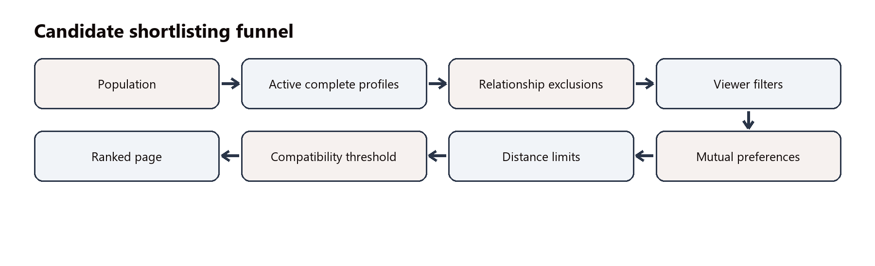
Figure 2. Population-to-page shortlisting funnel.

30 Discover Ranking
Default Discover ranks by compatibility score descending, then numeric candidate User ID ascending. The stable ID tie-break ensures that equal-scoring candidates have reproducible order. No recommendation path uses random order, shuffle, or ORDER BY RAND.

31 Near You Ranking
Near You ranks by precise six-decimal internal distance ascending, compatibility descending, then candidate User ID ascending. Only candidates that have valid coordinates and satisfy both distance limits reach this ranking stage. Public distance remains rounded and is not used as the continuation key.

32 AI Matches
AI Matches currently means a LOCAL deterministic recommendation provider. Shared Match Engine eligibility runs first. The LOCAL layer receives an opaque candidate user ID and canonical structured compatibility evidence, then reranks that eligible set. It cannot restore blocked, out-of-range, already-processed, matched, deactivated, deleted, or otherwise ineligible users.

33 AI Match Score
The current formula is aiMatchScore = clamp(compatibilityScore + round((coverage - 50) x 0.08), 0, 100). Coverage therefore provides a small calibration adjustment while canonical compatibility remains the dominant value.

34 AI Confidence
AI confidence is an evidence-support indicator, not a probability of mutual interest or relationship success. It combines 80 percent evidence coverage and 20 percent weighted factor support. The implementation labels 80 or above High, 50-79 Medium, and below 50 Low; these labels describe evidence support only.

35 AI Reasons
The provider generates at most three grounded highlights and reasons from positive available evidence. Priority areas are relationship goals, communication style, interests, languages, smoking, drinking, weed, and city. If no grounded reason exists, it uses the truthful fallback: 'Explore this profile to learn more about each other.'

Part IV Delivery Pagination and Match Creation

36 Discover Feed Delivery
GET /api/discover/feed authenticates the viewer, validates current completion, loads saved preferences and overrides, executes shared SQL eligibility and canonical scoring, applies deterministic ranking and keyset continuation, serializes only public fields, and returns profiles plus pagination and location capability metadata.

37 AI Matches Delivery
GET /api/discover/ai-matches forces the high_compatibility surface, uses the same candidate query, globally reranks the complete live eligible set with the LOCAL provider, applies AI keyset continuation, and returns recommendations plus provider, location, and pagination metadata.

38 Cursor and Keyset Pagination
Offset pagination can skip profiles after page-one swipes remove earlier rows. AMORAA instead resumes strictly after the last ranking tuple. Cursors are opaque, HMAC-SHA256 signed, limited to 2,048 characters, and bound to the viewer, surface, ranking version, effective filters, runtime defaults, and viewer/location context.
Live keyset pagination is mutation-safe for removed earlier candidates, but it is not a heavyweight historical snapshot. A profile edit that changes a future candidate's score or distance can reposition that candidate between requests; this is an explicit current contract.

39 Discover Cursor Ranking
Default Discover stores the last compatibility score and candidate User ID. Near You stores last internal distance, compatibility score, and User ID. Continuation uses the same comparison directions as server ranking, so the next request starts after the exact prior tuple.

40 AI Match Cursor
AI continuation uses AI Match Score descending, AI Confidence descending, and User ID ascending. The backend reranks the current eligible set globally, filters strictly after the cursor tuple, and then takes the next bounded page.

41 Mutual Like to Match
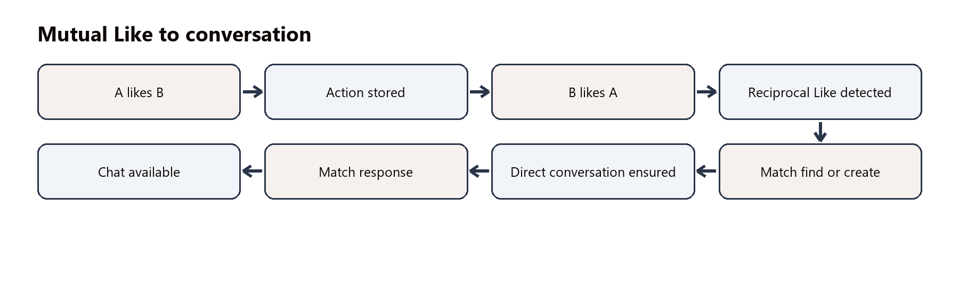
Figure 3. Transactional Mutual Like and Match creation flow.
When A likes or Super Likes B, the action is stored. If B has no reciprocal Like or Super Like, the relationship remains one-sided. When reciprocal interest exists, the backend locks the participants, uses Match.findOrCreate on the canonical ordered pair, and ensures the direct conversation in the same transaction. This provides duplicate protection for concurrent or repeated requests.

42 After Match Creation
The existing Match excludes the pair from recommendations. The Match and direct conversation become available through the relationship and chat layers. Messaging uses that actual relationship; a recommendation User ID is not a Match ID or conversation ID.

43 Message Flow from AI Matches
View Profile uses the candidate User ID. Message requests a conversation for that candidate, but the backend returns MATCH_REQUIRED unless a current active Match exists. The client never treats an AI recommendation identifier as a conversation identifier.

Part V Database API and Application Architecture

44 Database Architecture
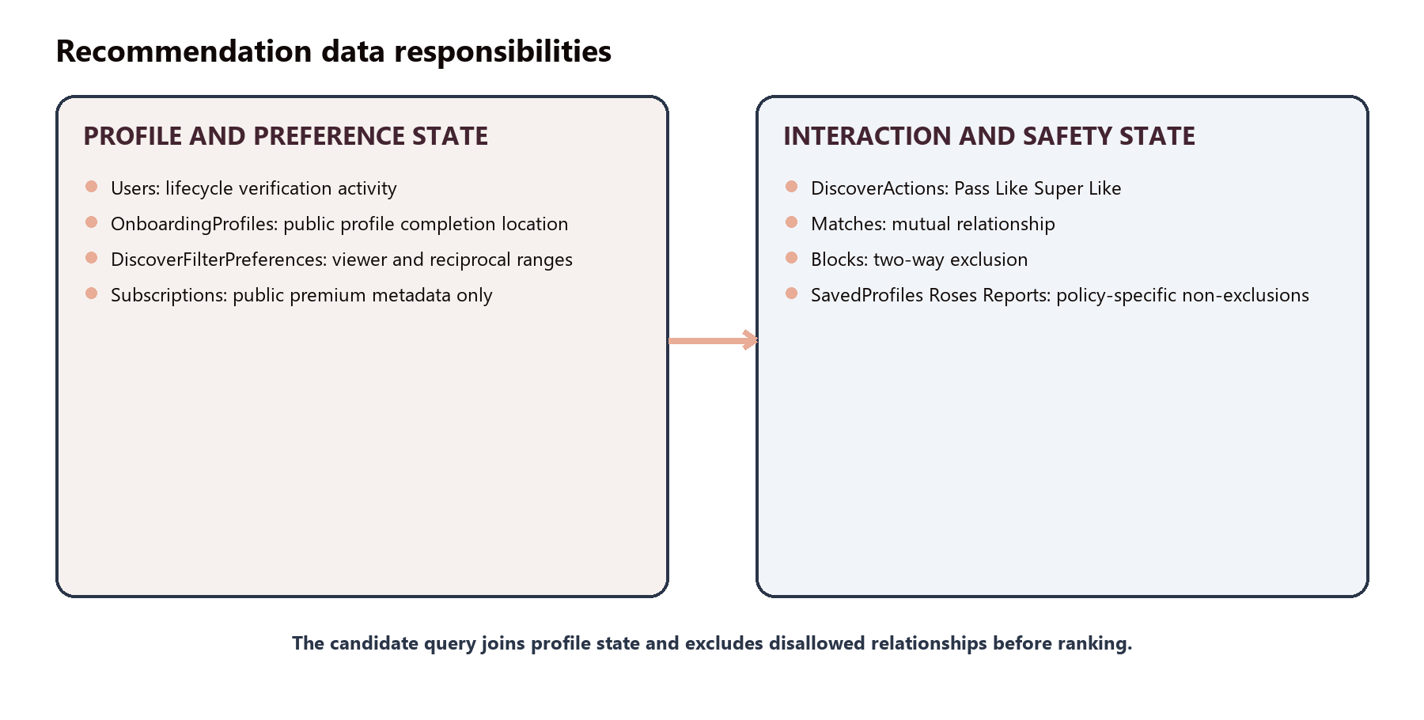
Figure 4. Database responsibilities relevant to recommendation and relationship state.

45 Database Table Responsibility
Table 9. Database model responsibilities
Table or model | Purpose | Important data | Match Engine role
Users | Lifecycle, verification, recent activity | accountStatus, identityVerifiedAt, lastActiveAt | Read; auth/lifecycle writes
OnboardingProfiles | Profile, completion, private location | DOB, gender, lists, photos, coordinates | Read; profile/location writes
DiscoverFilterPreferences | Viewer and reciprocal preferences | age, distance, hard filters, minScore | Read/write
DiscoverActions | Swipe history | actor, target, pass/like/superLike | Exclude; swipe/rewind writes
Matches | Mutual relationship | ordered participant pair, matchedAt | Exclude; mutual Like writes
Blocks | Two-way safety exclusion | blocker and blocked IDs | Exclude; block writes
SavedProfiles | Bookmark relationship | user and saved user | Not an exclusion
RoseTransactions | Rose delivery and reversal | sender, recipient, status | Not an exclusion
Reports | Safety case | reporter, target, reason, status | Not an automatic exclusion
EventRegistrations | Event-interest filter | user, event, status | Read; registered only
Subscriptions | Public premium metadata | status and period end | Serializer read only

46 Backend API Overview
Table 10. Verified backend API reference
Method | Endpoint | Purpose | Auth | Important result
GET | /api/discover/feed | Discover recommendations | Bearer | Public profiles and cursor
GET | /api/discover/ai-matches | LOCAL AI recommendations | Bearer | Provider, recommendations, cursor
GET / PUT | /api/me/preferences | Read or save filters | Bearer | Canonical preferences
GET / PUT / DELETE | /api/me/location | Read availability, save, or clear private location | Bearer | Availability and server timestamp
POST | /api/discover/swipe | Pass, Like, or Super Like | Bearer | Action; optional Match and conversation
POST | /api/discover/rewind | Remove latest DiscoverAction | Bearer | Rewound target and action
POST | /api/roses/send | Send a Rose | Bearer | Rose transaction
GET | /api/profiles/:userId | Public profile detail | Bearer | Candidate User ID profile
GET | /api/matches | List current matches | Bearer | Match IDs and profiles
GET / DELETE | /api/matches/:matchId | Read or remove a Match | Bearer | Match state
POST | /api/conversations | Create or retrieve direct chat | Bearer | Requires active Match
PUT / DELETE | /api/me/saved-profiles/:userId | Save or unsave a profile | Bearer | Bookmark relationship

47 Frontend to Backend Technical Flow
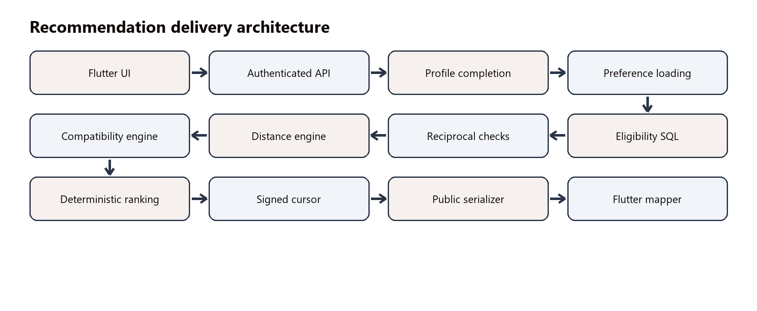
Figure 5. Shared Flutter-to-database recommendation delivery path.
Discover sequence: BrowseGridScreen -> DiscoverApiService -> GET /api/discover/feed -> requireAuth -> discoverController.getFeed -> discoverPreferenceService -> discoverEligibilityPolicy and eligibility SQL -> compatibilityScoringService -> recommendationCursorService -> publicProfileService -> publicProfileFromJson -> Discover cards.
AI sequence: MatchesScreen -> PhaseTwoApiService.aiRecommendations -> GET /api/discover/ai-matches -> the same authoritative candidate query and compatibility -> aiMatchProvider LOCAL reranking -> AI cursor -> serializer -> profile mapper -> AI Matches screen.

48 Error Handling
Table 11. Controlled recommendation conditions
Condition | Response | Meaning
Authentication failure | 401 | Request is rejected; not an empty feed
Incomplete profile | 403 ONBOARDING_INCOMPLETE | User completes canonical requirements
Invalid filter | 400 VALIDATION_ERROR | Field-specific validation response
Location required | 409 LOCATION_REQUIRED | Near You requires saved coordinates
Unsupported surface | 400 DISCOVER_SURFACE_UNSUPPORTED | No silent no-op behavior
Invalid cursor | 400 PAGINATION_CURSOR_INVALID | Restart from first page
Cursor context changed | 400 PAGINATION_CONTEXT_CHANGED | Reload after filter/location change
Page without cursor | 400 PAGINATION_CURSOR_REQUIRED | Use preceding nextCursor
Match required for chat | 403 MATCH_REQUIRED | Create chat only after Match
No eligible candidates | 200 with empty list | Valid empty state, not an API error

49 No More Matches Available
A true empty result can mean the current population has no eligible candidates, all candidates were processed, filters are restrictive, mutual preferences do not align, distance limits exclude the pool, or block/Match state removes the remaining profiles. The backend returns an empty array and exhausted pagination; it does not insert dummy fallback profiles.

50 Filter Specific Empty State
Flutter distinguishes a server-empty feed, a locally filtered-empty view, loading, continuation failure, and API error. When a local quick filter hides the loaded AI page and the server has more pages, the screen boundedly loads later cursor pages before declaring no visible result. Product guidance can invite users to review existing filters without promising profiles that do not satisfy the contract.

Part VI Privacy Security Observability and Performance

51 Privacy and Consent
The recommendation design follows data-minimization principles compatible with AMORAA's DPDP-oriented privacy approach. Profile and preference data are used for the matching purpose; current location is captured only after a foreground user action; exact GPS and private reciprocal ranges remain server-side; and users can update or clear their matching location and preferences.
Passwords, OTPs, tokens, private messages, payment data, KYC records, deletion reasons, and moderation case details are not inputs to compatibility or LOCAL AI. No retention period is asserted by this report. Deactivated and deleted users are excluded from recommendation participation.

52 Security
- Recommendation, preference, location, action, profile, Match, and conversation APIs require authentication.
- Eligibility is calculated on the server; Flutter cannot authorize a candidate by itself.
- Cursors are signed, versioned, viewer-bound, surface-bound, and context-bound.
- Numeric candidate and relationship IDs are validated; self-actions and unavailable targets fail closed.
- Exact coordinates and private account fields are omitted by the public serializer.
- Unique action/relationship constraints and transactional Match creation reduce duplicate state.

53 Observability
Privacy-safe recommendation diagnostics are opt-in through MATCH_ENGINE_OBSERVABILITY_ENABLED=true. They record bounded surface, provider, duration bucket, error class, score/coverage buckets, continuation state, and aggregate candidate counts before eligibility, after eligibility, after distance, and returned.
The service does not log user or candidate IDs, city, filters, cursor values, coordinates, sexuality, profile content, reciprocal limits, credentials, KYC, messages, payments, or deletion reasons. Unknown labels collapse into bounded categories to prevent unsafe high-cardinality metrics.

54 Performance
Table 12. Certified local test measurements
Eligible candidates | Discover ms / queries | Near You ms / queries | LOCAL AI ms / queries
100 | 564 ms / 10 | 626 ms / 10 | 509 ms / 10
500 | 1,962 ms / 10 | 1,964 ms / 11 | 2,129 ms / 10
1,000 | 3,773 ms / 11 | 3,669 ms / 10 | 3,760 ms / 11
5,000 | Not tested | Not tested | Not tested

These are local MariaDB regression measurements, not production latency or SLA commitments. Query count stays bounded as the candidate pool grows; the small variation reflects the throttled authentication activity update rather than candidate-proportional reads.

55 Database Performance
Phase 7 added reverse composite indexes Matches(userTwoId,userOneId) and Blocks(blockedUserId,blockerUserId) to complement the forward pair indexes used by bidirectional exclusions. Candidate preferences, coordinates, scoring, reciprocity, and serialization do not introduce N+1 queries.
Known future scale costs are computed normalized compatibility, Haversine/filesort work, and full eligible-set LOCAL AI materialization. Spatial bounding, persisted normalized projections, and versioned AI ranking caches should be considered only after production-like measurement confirms the need.

56 Current Test Certification
Table 13. Final automated certification
Gate | Passed or errors | Failed or warnings | Skipped or infos
Backend | 311 passed | 0 failed | 0 skipped
Flutter | 627 passed | 0 failed | 14 skipped
Analyzer | 0 errors | 38 warnings | 5 infos; no new diagnostics
Git integrity | git diff --check PASS | - | -

Physical-device final Match Engine smoke testing was not completed because no device was connected during certification. This is reported separately and is not presented as a physical PASS.

57 Current APK and Environment Note
The Match Engine is certified by the clean backend and Flutter automated suites. The final debug APK attempt was blocked before application compilation by a Windows/Java PipeImpl loopback host-environment failure under Java 22 and Android Studio Java 21. This is an environment issue, not a Match Engine defect, and this report does not claim that the full application is production deployed.

Part VII Examples and Frequently Asked Questions

58 Business Example
Illustrative fictional example. Aisha is 28, lives in Pune, seeks a long-term relationship, prefers ages 26-32 within 40 km, and is interested in men. Neel is 29, lives 12 km away, seeks a long-term relationship, prefers ages 25-31 within 25 km, and is interested in women. Both profiles are active and complete, with no block, Match, or prior terminal action.
Table 14. Fictional Aisha and Neel compatibility evidence
Factor | Aisha | Neel | Contribution
Interests | Travel, Music, Movies | Travel, Music, Cricket | 2/3 x 35 = 23.33
Relationship goals | Long-term | Long-term | 1 x 25 = 25
Communication style | Deep conversations | Deep conversations | 1 x 10 = 10
Languages | English, Hindi | English, Hindi, Gujarati | 2/3 x 10 = 6.67
City | Pune | Pune | 1 x 5 = 5
Smoking | Never | Never | 1 x 5 = 5
Drinking | Occasionally | Occasionally | 1 x 5 = 5
Weed | Never | Never | 1 x 5 = 5

All 100 points of evidence are available. Weighted Agreement is 85, Raw Score is 85, Coverage is 100 percent, and Final Compatibility is 85. The LOCAL AI adjustment adds 4 points, producing an illustrative AI Match Score of 89 and evidence-support confidence of 97. If Aisha likes Neel and Neel later likes Aisha, the backend creates or retrieves the Match and direct conversation. These numbers explain the implemented formula; they do not predict relationship success.

59 Match Engine Decision Example
A candidate may have compatibility 92 but still be ineligible. If the actual distance is 22 km and the candidate's reciprocal maximum is 10 km, the pair fails reciprocal distance. Hard eligibility runs before ranking, so the 92 score cannot override the candidate's stated limit.

60 Management FAQ
Table 15. Management frequently asked questions
Question | Answer
Does AMORAA randomly show profiles? | No. Ranking is deterministic with stable User ID tie-breakers.
Does AI decide who users may see? | No. The Match Engine establishes eligibility before LOCAL AI reranks.
Does AMORAA use ChatGPT or another external model? | No external matching model is implemented today.
Can a blocked person appear again? | Not while either-direction block exists.
Can a passed profile appear again? | Not while the Pass action exists; verified rewind/reset behavior can remove it.
Does AMORAA expose exact location? | No. Public responses include only rounded distance.
Can someone outside either distance limit appear? | Not when geographic filtering is active.
What happens after two Likes? | A Match is created or retrieved and direct conversation eligibility is established.
Does a high score guarantee success? | No. It summarizes stated profile alignment, not relationship outcomes.
Why might Discover be empty? | Population, actions, blocks, mutual preferences, distance, or restrictive filters may leave no eligible profile.

61 Technical FAQ
Table 16. Technical frequently asked questions
Topic | Answer
Authoritative score engine | Backend/src/services/compatibilityScoringService.js
Why cursor pagination | It prevents offset skips after earlier candidates become ineligible.
Reciprocal age | Viewer age must fall inside the candidate's effective minAge/maxAge.
Distance calculation | One symmetric Haversine distance is checked against both effective maximums.
Compatibility vs AI score | Compatibility is canonical factor alignment; AI score is a modest coverage-adjusted reranking score.
Missing evidence | Unavailable factors reduce coverage and pull the final score toward neutral.
LOCAL vs external AI | LOCAL is executable and deterministic; external AI is not implemented.
Recommendation ID | Candidate User ID, never Match or conversation ID.
N+1 prevention | Eligibility, reciprocal preference, distance, scoring, and pagination remain in bounded SQL queries.

Part VIII Boundaries Roadmap and Complete Flow

62 Current Deliberate Limitations
The following are future enhancements or explicit product choices, not blockers to the certified current Match Engine:
- External model-backed AI; realtime socket presence; background GPS; automatic location expiry.
- similar_interests, new_here, and recently_active ranking surfaces.
- Automatic report-to-block behavior; Rose-based exclusion; Save-based exclusion.
- Heavyweight historical ranking snapshots and production-evidence-driven spatial optimization.
- Persisted normalized compatibility projections; versioned AI ranking cache; 5,000-candidate benchmark.
- Final physical-device smoke testing when a device is available.

63 Future Match Engine Improvements
Table 17. Evidence-driven future roadmap
Horizon | Potential work
Short term | Production performance monitoring; 5,000+ candidate benchmark; physical-device validation; richer bounded observability; additional approved surfaces
Medium term | Realtime presence; location freshness policy; measured spatial bounding/indexing; additional safe compatibility evidence
Long term | Optional external reranking; improved explanations; privacy-safe learning from aggregated outcomes; experimentation framework

64 Match Engine Versus AI
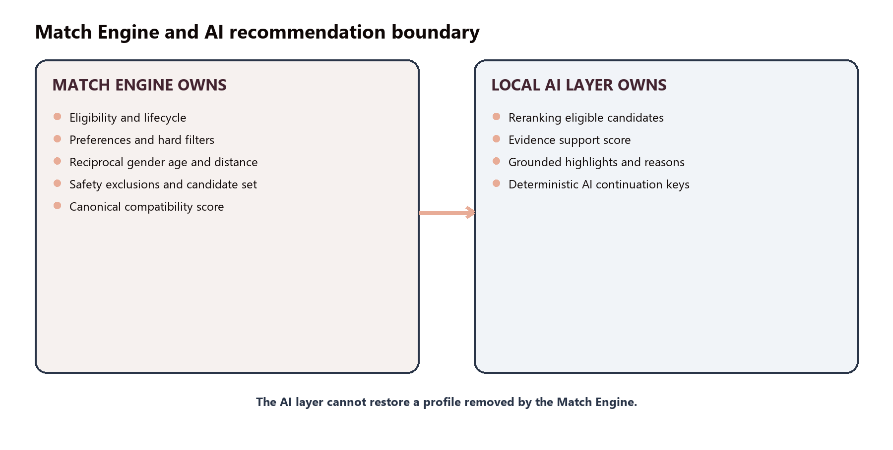
Figure 6. Eligibility authority remains with the Match Engine; LOCAL AI reranks only eligible profiles.
Any future external provider must preserve this boundary. It may rerank already-eligible opaque IDs and explain approved structured evidence. It must not bypass a block, age, distance, Match, lifecycle state, or action exclusion, and it must not receive credentials, exact GPS, KYC, private messages, payment data, or moderation details.

65 Complete End to End Flow
1. The user authenticates; the backend validates account lifecycle and token state.
2. The backend loads the viewer profile and validates current canonical completion.
3. Saved preferences and runtime defaults are loaded; approved request overrides are validated.
4. The candidate query excludes self and requires active accounts with complete profiles.
5. Either-direction blocks, existing Matches, and prior Pass, Like, or Super Like actions are removed.
6. Viewer interestedIn and candidate reciprocal interestedIn are evaluated.
7. Viewer age range and candidate reciprocal age range are evaluated.
8. Selected hard profile, verification, activity, event, and prompt filters are applied.
9. When location is available, candidates need valid coordinates and one exact distance must satisfy both limits.
10. Canonical SQL compatibility and coverage are calculated; minimum compatibility is applied.
11. Default, Near You, or LOCAL AI ranking is applied deterministically.
12. Signed keyset continuation selects the current page without mutation-prone offsets.
13. The public serializer removes private state and returns candidate User IDs plus approved profile fields.
14. Flutter maps the response, preserves server order, appends unique IDs, and distinguishes empty and error states.
15. Pass, Like, and Super Like persist action history and remove processed profiles.
16. A reciprocal Like or Super Like creates or retrieves the Match and direct conversation transactionally.
17. Messaging uses the actual Match and conversation relationship, never the recommendation ID as a conversation ID.

66 Final Management Summary
The current AMORAA Match Engine provides deterministic recommendations, reciprocal gender/age/distance eligibility, real geographic filtering, explainable compatibility, interaction-aware candidate removal, privacy-preserving signed pagination, and deterministic LOCAL AI recommendations. The backend architecture keeps eligibility authoritative and gives future AI work a clear, restricted boundary.
The engine is complete for the present product scope, supported by 311 passing backend tests, 627 passing Flutter tests, zero analyzer errors, and a passing Git integrity check. It does not claim perfect matching, scientific relationship prediction, external AI, realtime presence, production deployment, or completed physical-device certification.

Appendices

Appendix A Compatibility Weight Reference
Factor | Weight | Agreement
Interests | 35 | Normalized intersection / larger list
Relationship Goals | 25 | Normalized intersection / larger list
Communication Style | 10 | Exact normalized equality
Languages | 10 | Normalized intersection / larger list
City | 5 | Exact normalized equality
Smoking | 5 | Exact normalized equality
Drinking | 5 | Exact normalized equality
Weed | 5 | Exact normalized equality

Appendix B Filter Reference
Viewer-side hard filters are age, distance when evaluable, minimum height, city, dating intentions, sexuality, education, profession, community, religion, smoking, drinking, weed, languages, pronouns, qualities, preferred talking hours, love languages, lifestyle tags, communication styles, prompts, verified-only, recent activity, registered-event interest, and minimum compatibility. Only gender, age, and distance are reciprocal.

Appendix C Action Exclusion Matrix
State | Discover | AI Matches
Pass | Yes | Yes
Like | Yes | Yes
Super Like | Yes | Yes
Existing Match | Yes | Yes
Block | Yes | Yes
Rose | No | No
Save | No | No
Report | No | No

Appendix D Database Table Reference
The definitive model responsibilities are summarized in Table 9. Canonical joins use Users, OnboardingProfiles, DiscoverFilterPreferences, DiscoverActions, Matches, Blocks, EventRegistrations, and optional Subscription metadata. Saves, Roses, and Reports retain their explicit non-exclusion policies.

Appendix E Backend API Reference
The verified current endpoints are listed in Table 10. Match creation is not a separate public recommendation endpoint: it occurs during POST /api/discover/swipe when a reciprocal Like or Super Like is found.

Appendix F Error Code and Fallback Reference
The controlled recommendation conditions are listed in Table 11. Empty results are successful responses, not failures. There are no hardcoded fallback profiles. LOCAL AI's only explanatory fallback is the bounded truthful reason used when no positive factor evidence is available.

Appendix G Test Certification Summary
Backend: 311 passed, 0 failed, 0 skipped. Flutter: 627 passed, 0 failed, 14 skipped. Analyzer: 0 errors, 38 warnings, 5 infos, no new diagnostics. git diff --check: PASS. Debug APK: host-environment failure before compilation. Physical device: not tested because no device was connected.

Appendix H Glossary
Term | Meaning
Candidate | A user profile being evaluated for possible recommendation.
Eligibility | The hard rules that determine whether a candidate may appear.
Compatibility Score | A 0-100 coverage-calibrated summary of eight stated profile factors.
Coverage | The percentage of weighted compatibility evidence available.
Reciprocal Preference | A candidate preference that the viewer must also satisfy.
Discover | The standard recommendation feed.
Near You | Distance-first eligible recommendation ranking requiring viewer coordinates.
AI Matches | The LOCAL deterministic reranked view of the same eligible candidate set.
LOCAL AI | The in-process deterministic recommendation provider; not an external model.
Hard Filter | A selected condition that can remove a candidate before ranking.
Cursor | An opaque signed continuation token containing technical ranking state.
Keyset Pagination | Continuation after the last ranking tuple instead of by row offset.
Match | The canonical relationship created after reciprocal Like or Super Like.
Conversation | The direct chat relationship enabled by an active Match.

Source and Implementation Reference
This report reflects the current working tree and final certification. Principal implementation references are discoverController.js, discoverEligibilityPolicy.js, discoverPreferenceService.js, compatibilityScoringService.js, aiMatchProvider.js, recommendationCursorService.js, publicProfileService.js, matchEngineContract.js, geoDistance.js, the relevant Sequelize models and routes, DiscoverApiService, PhaseTwoApiService, BrowseGridScreen, MatchesScreen, AdvancedFiltersScreen, MatchLocationService, and publicProfileFromJson.
Contract version: v2. Ranking and cursor version: v2:cursor-1. Current provider: LOCAL.

